1. Deployed windows 2016 datacenter gen 1 in Microsoft Azure and named the virtual machine windows16pa in myResource resource group located at EAST US 2.

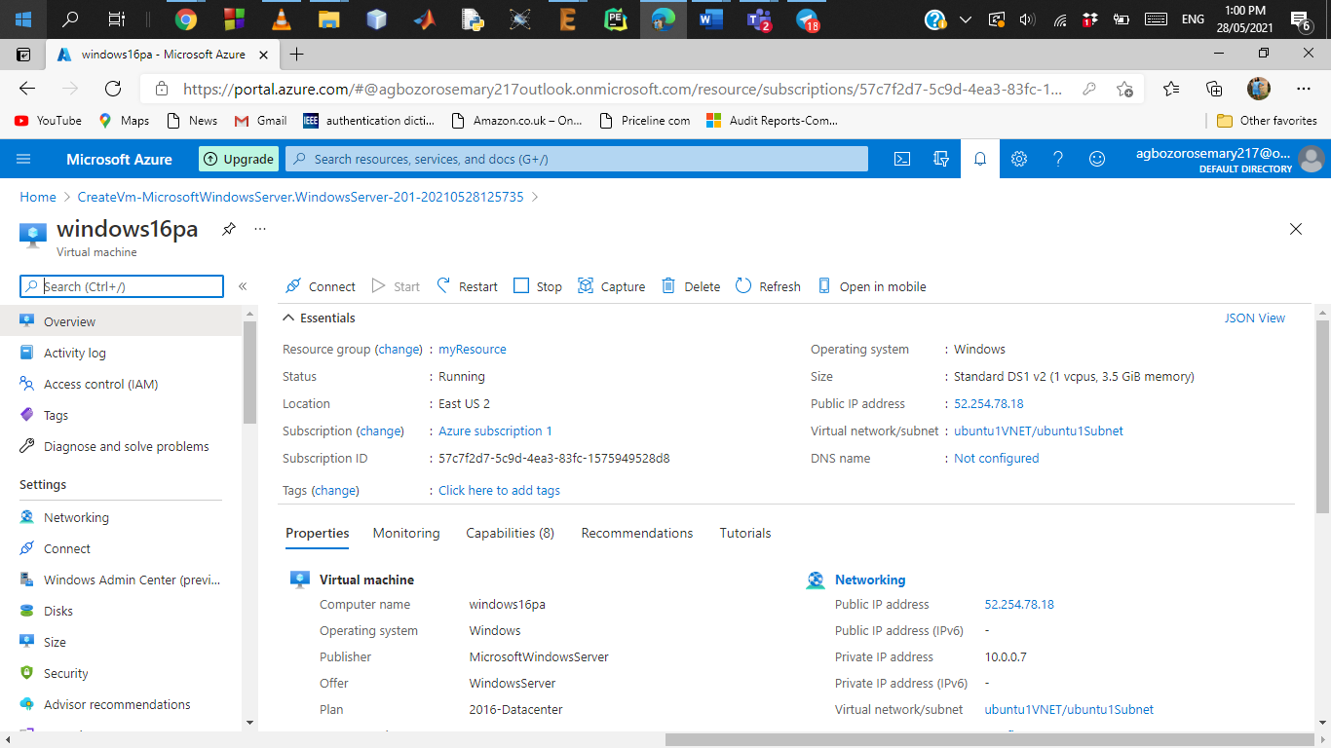

1. Installing the windows feature web server tools successfully from the PowerShell in the desktop version of the remote computer (windows16)

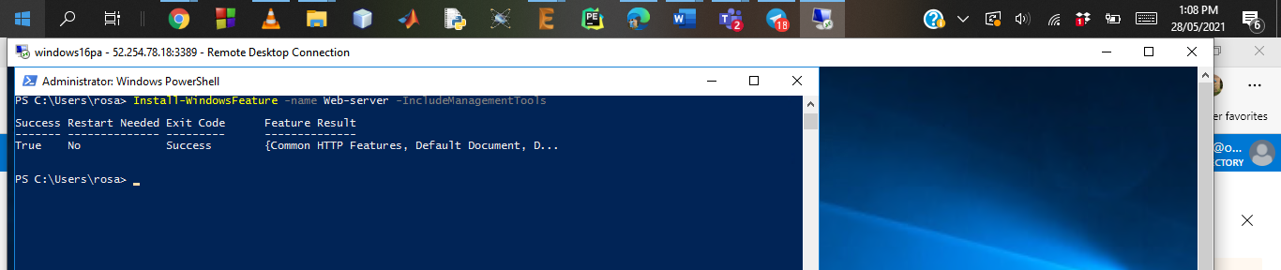

Using the browser to check the public IP address connection (public IP – 52.254.78.18).

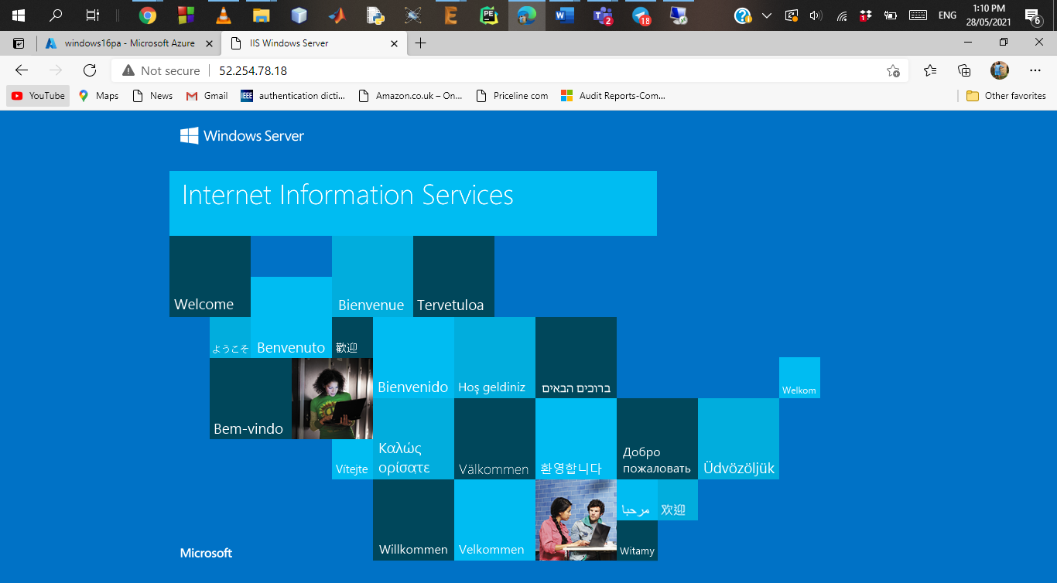

1. Created a site recovery vault called ‘paVault’ in a resource group (the target resource group) called target-rg in WEST US 2. 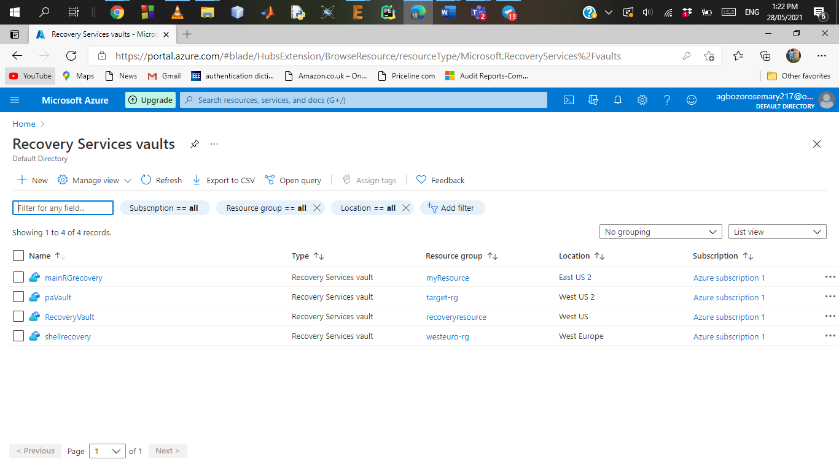

Added the windows16pa virtual machine as a replicated item in the recovery service vault. I enabled replication first.

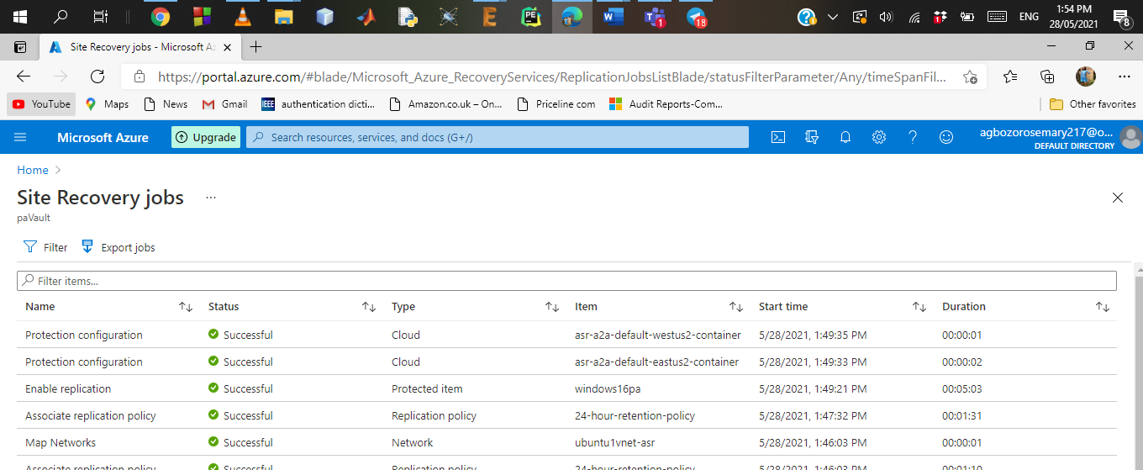

Replication successful and status changed to protected.

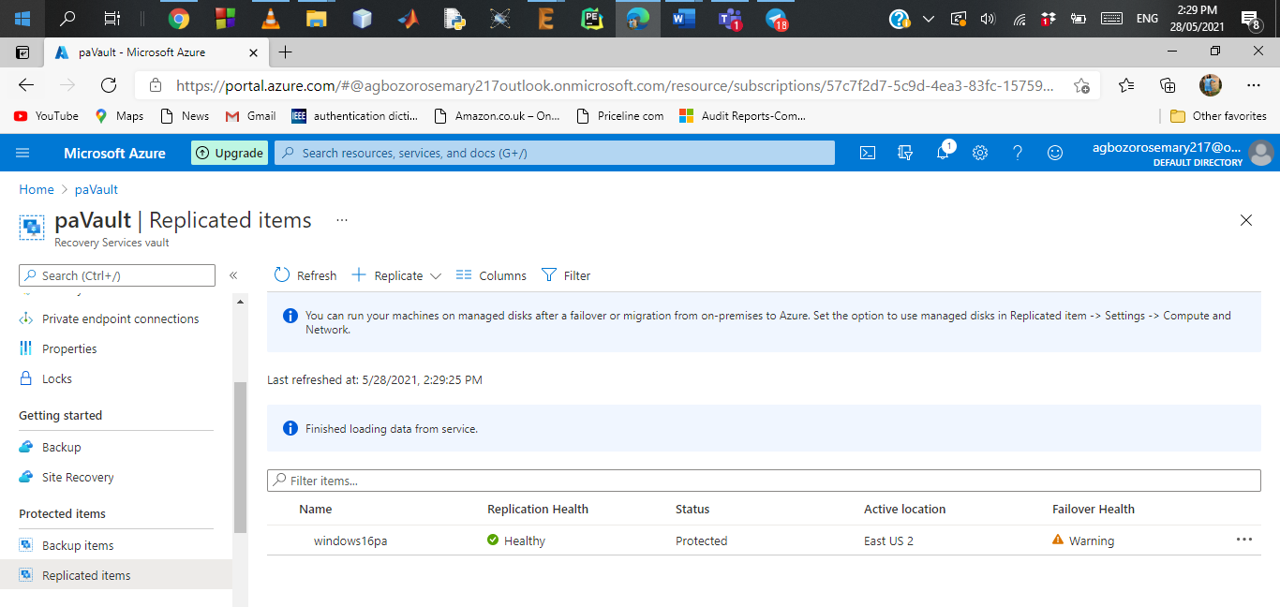

1. Stopping the VM (Windows16pa) in the primary region (EAST US 2) to serve as a breakdown.

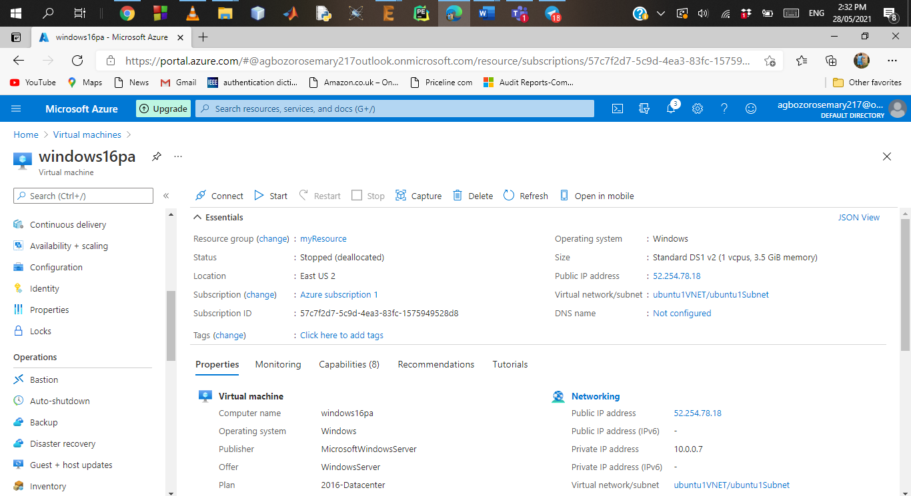

1. Run test failover. VM replication was created in the target area (target-rg in location WEST US 2).

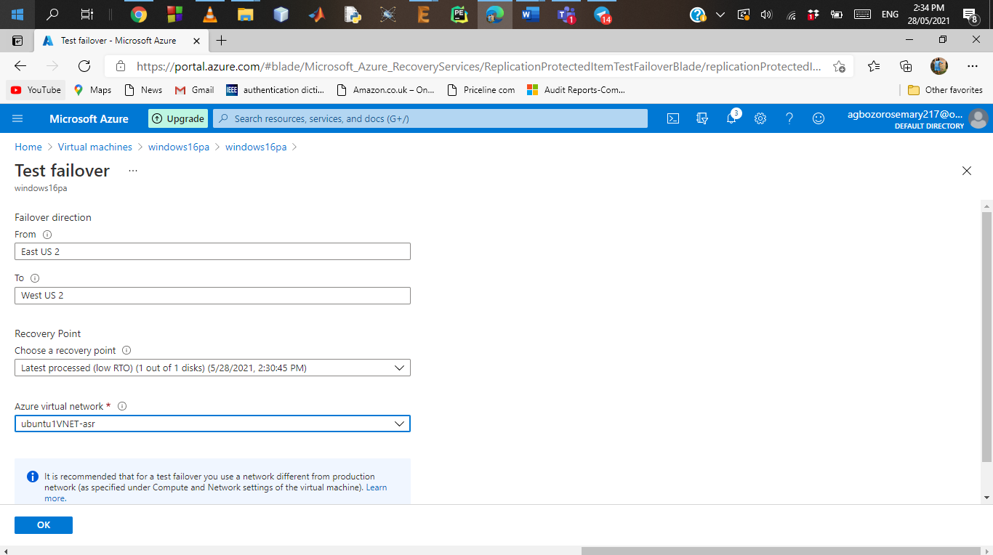

The windows16pa-test virtual machine created in target resource group

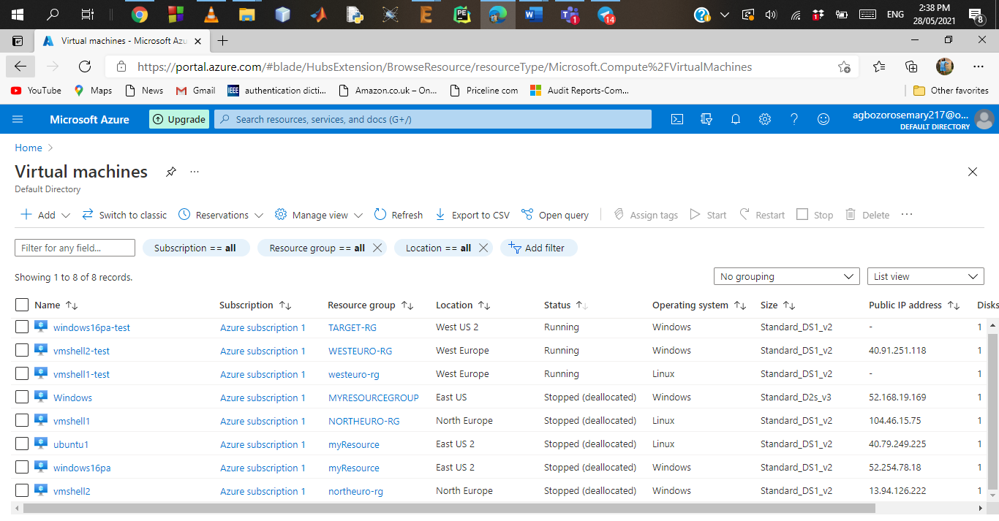

1. Configuring Public IP for test virtual machine and setting ports. This is so we can establish a remote desktop connection as well as view the

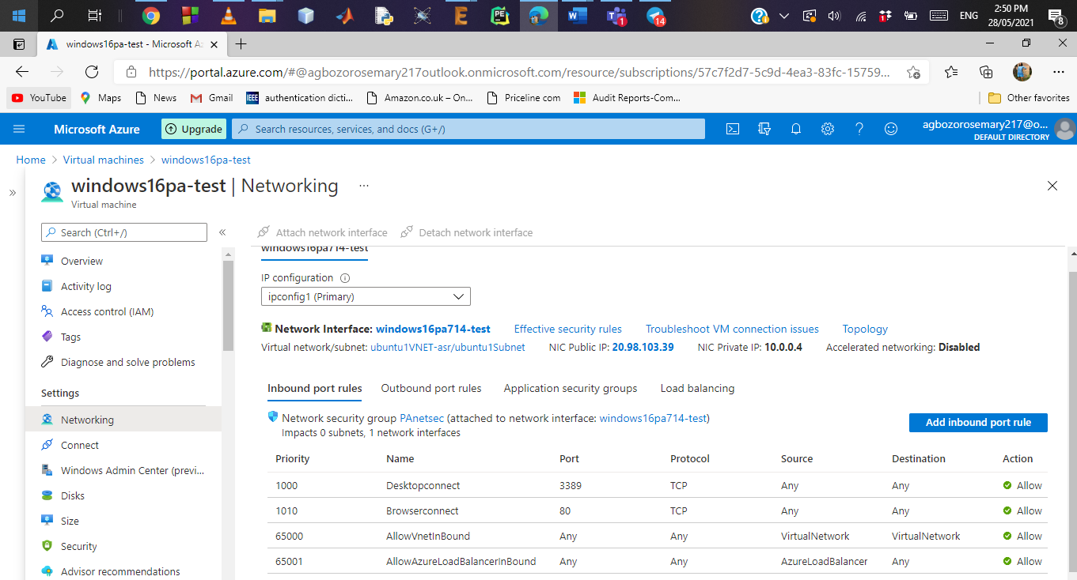

1. Running test Virutal machine remotely on my desktop

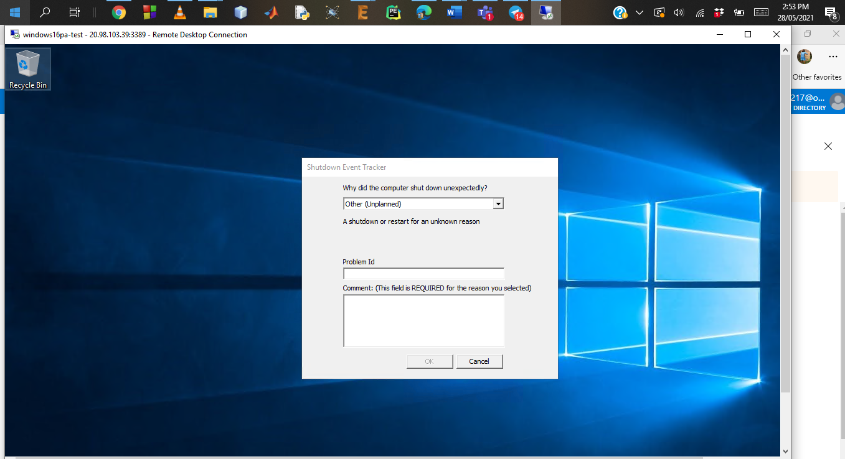

1. Browser test to ensure IP working

